Database Relationship Analysis Using Joins
Project Title: Multi-Table Order & Payment Reporting System
Project Title : Multi-Table Order & Payment Reporting System
Student Name : Anusri R
Register Number : C4S38001
Department : B.Sc Artificial Intelligence
Course : Artificial Intelligence (AI)
Academic Year : 2024 - 2027
Database Relationship Analysis Using Joins
1. Create Customer Table
CREATE TABLE Customer (
CustomerID INT PRIMARY KEY,
CustomerName VARCHAR(50),
Email VARCHAR(50),
City VARCHAR(50)
);
2. Create Product Table
CREATE TABLE Product (
ProductID INT PRIMARY KEY,
ProductName VARCHAR(50),
Category VARCHAR(50),
Price INT
);
3. Create Orders Table
CREATE TABLE Orders (
OrderID INT PRIMARY KEY,
CustomerID INT,
ProductID INT,
OrderDate DATE,
Quantity INT,
FOREIGN KEY (CustomerID) REFERENCES Customer(CustomerID),
FOREIGN KEY (ProductID) REFERENCES Product(ProductID)
);
4. Create Payment Table
CREATE TABLE Payment (
PaymentID INT PRIMARY KEY,
OrderID INT,
PaymentDate DATE,
Amount INT,
PaymentMethod VARCHAR(20),
Status VARCHAR(20),
FOREIGN KEY (OrderID) REFERENCES Orders(OrderID)
);
5. Insert Sample Customers
INSERT INTO Customer VALUES
(1, 'Arun', 'arun@mail.com', 'Chennai'),
(2, 'Kumar', 'kumar@mail.com', 'Madurai'),
(3, 'Ravi', 'ravi@mail.com', 'Trichy'),
(4, 'Divya', 'divya@mail.com', 'Coimbatore');
6. Insert Sample Products
INSERT INTO Product VALUES
(101, 'Laptop', 'Electronics', 50000),
(102, 'Mobile', 'Electronics', 20800),
(103, 'Headset', 'Accessories', 800);
7. Insert Sample Orders
INSERT INTO Orders VALUES
(1, 1, 101, '2026-08-08', 1),
(2, 2, 102, '2026-08-08', 1),
(3, 2, 103, '2026-08-09', 1),
(4, 3, 103, '2026-08-09', 2);
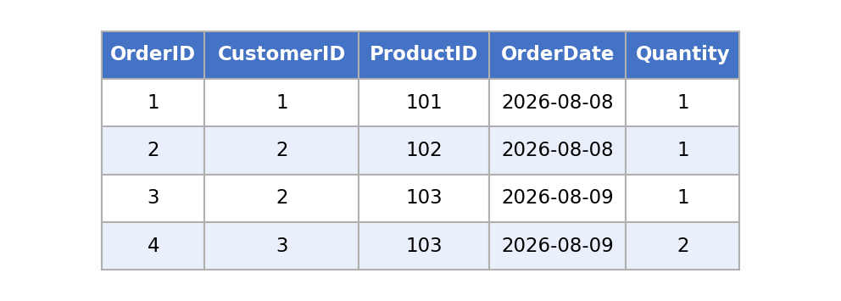
8. Insert Sample Payments
Note: Order 4 (Ravi) has no payment yet, so it can show unmatched rows in JOIN results below.
INSERT INTO Payment VALUES
(1, 1, '2026-08-08', 50000, 'UPI', 'Paid'),
(2, 2, '2026-08-08', 20800, 'Card', 'Paid'),
(3, 3, '2026-08-09', 800, 'Cash', 'Paid');
9. INNER JOIN - Retrieve Complete Order Details
SELECT
Orders.OrderID,
Customer.CustomerName,
Product.ProductName,
Orders.OrderDate,
Orders.Quantity,
Product.Price
FROM Orders
INNER JOIN Customer
ON Orders.CustomerID = Customer.CustomerID
INNER JOIN Product
ON Orders.ProductID = Product.ProductID;
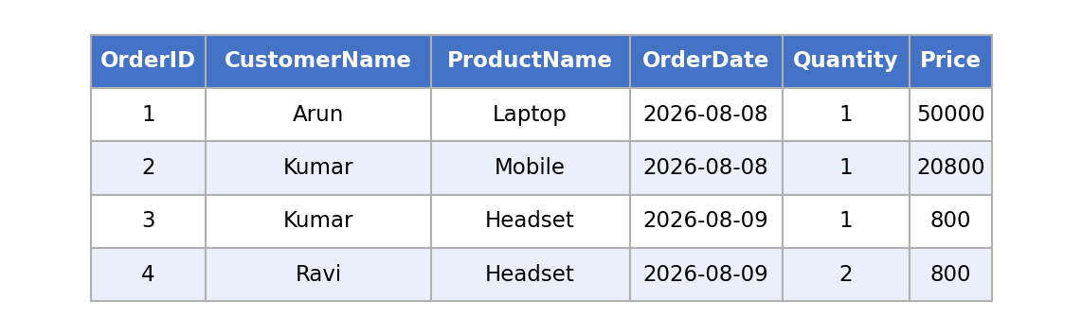
10. LEFT JOIN - Customer Purchase History
This shows every customer, even Divya who has not placed any order yet (missing values appear as NULL).
SELECT
Customer.CustomerName,
Orders.OrderID,
Product.ProductName,
Orders.OrderDate
FROM Customer
LEFT JOIN Orders
ON Customer.CustomerID = Orders.CustomerID
LEFT JOIN Product
ON Orders.ProductID = Product.ProductID;
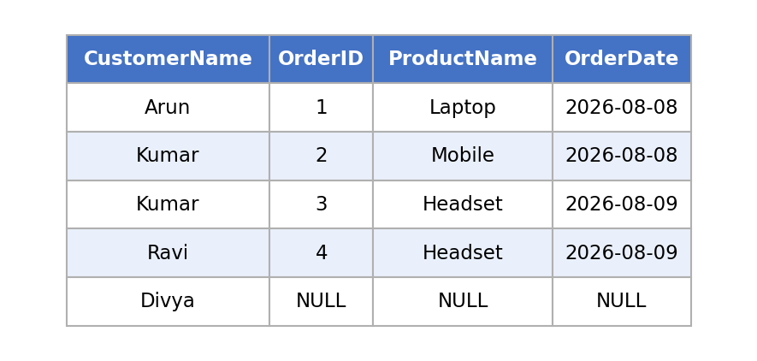
11. RIGHT JOIN - Payment Report for All Orders
This keeps every order, even Order 4 which has no payment yet (missing values appear as NULL).
SELECT
Orders.OrderID,
Customer.CustomerName,
Payment.Amount,
Payment.PaymentMethod,
Payment.Status
FROM Payment
RIGHT JOIN Orders
ON Payment.OrderID = Orders.OrderID
LEFT JOIN Customer
ON Orders.CustomerID = Customer.CustomerID;
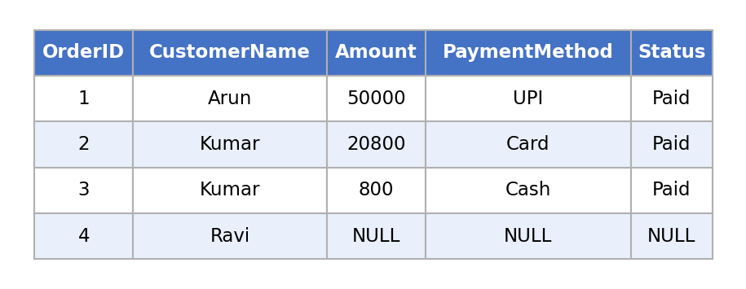
12. Multi-Table Report (Customer + Product + Orders + Payment)
SELECT
Customer.CustomerName,
Product.ProductName,
Orders.OrderDate,
Orders.Quantity,
Payment.Amount,
Payment.Status
FROM Orders
JOIN Customer ON Orders.CustomerID = Customer.CustomerID
JOIN Product ON Orders.ProductID = Product.ProductID
LEFT JOIN Payment ON Orders.OrderID = Payment.OrderID;
